https://www.thoughtco.com/remove-a-background-in-adobe-photoshop-4072079:
How To Remove A Background In Adobe Photoshop


Computer Science
- Graphic Design
  - Tutorials & Other Resources
  - Basics
  - Graphics Software
  - Free Downloads
  - Adobe Illustrator Resources
  - Adobe Photoshop Resources
  - Computer Aided Design
- PHP Programming Language
- Perl Programming Language
- Python Programming
- Java Programming
- JavaScript Programming
- Delphi Programming
- C & C++ Programming
- Ruby Programming
- Visual Basic
- Web Design
- Databases
- Office Software
- Open Source
- Spreadsheets
- Desktop Publishing
- Presentation Software
- Animation
- Broadband
- Assistive Technologies
View More

You Start With A Rather Complex Selection
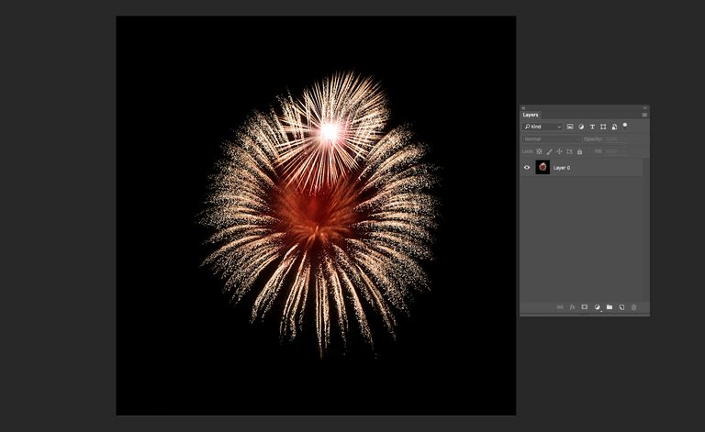
Pulling the fireworks explosion out of this image requires more than a selection tool. Getty Images
It may seem like a real challenge to pull the fireworks out of this image. The selection tools won't work, and the background eraser didn't produce very good results either. I'm going to show you an amazingly simple technique for masking the fireworks in this image using the channels panel.
The total time isolating the fireworks was under four minutes. This technique doesn't always work this smoothly for every image, but it can be used in combination with other methods for making more complex selections. In the fifth example on removing backgrounds with Photoshop, you'll see how this technique was expanded on and combined with other methods for masking a more complicated image. If you're not familiar with masks, you may find it helpful to read an earlier article, All About Grayscale Masks.
Updated by Tom Green

How To Use Channels In Adobe Photoshop
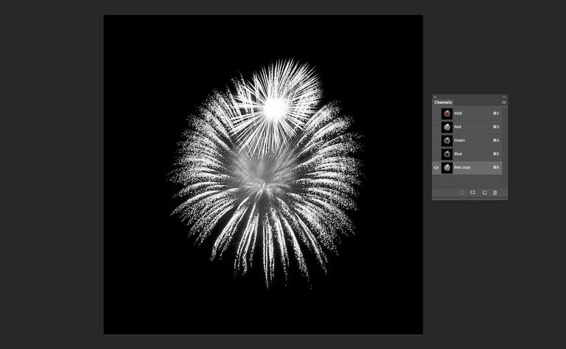
Channels give you the best view of a potential mask.
The first step is to look at the channels palette and determine which color channel best represents the area we want to capture. To the right, shown from top to bottom, you can see the red, blue, and green channels for this image. It's obvious that the red channel contains the most information for capturing the fireworks.The information is the white colour because the channel will eventually become a selection .
In the channel palette, click on the red channel and drag it down to the new channel button.
This creates a duplicate of the red channel as an alpha channel. Alpha channels are a way of saving selections that can be loaded at any time. In addition, they can be edited with painting tools like a grayscale mask.

How To Select The Background In A Channel
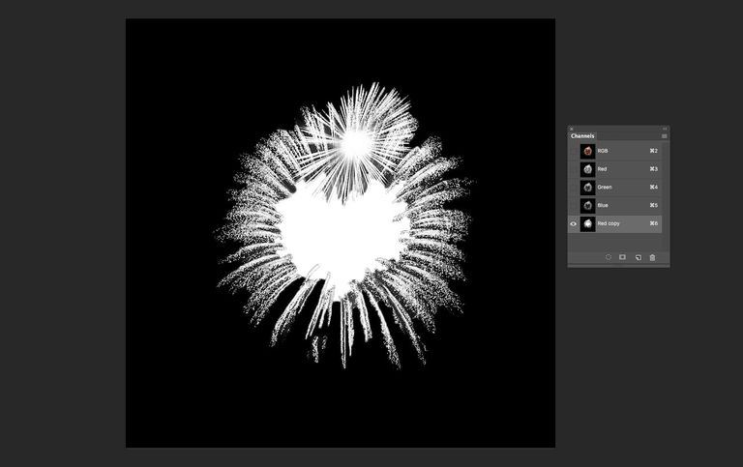
Use the Quick Selection tool to select the background and then fill it with black and the flower with white.
To isolate the exploding firework you need the paint out the background. You want to be sure that your new channel is the active channel before you start painting
A quick way of doing this is to switch to the Quick Selection tool. Increase the brush size by pressing the ]-key and make sure black is your foreground colour. Drag around the background and when everything but the explosion is selected, choose Edit>Fill> Foreground Colour. . Now we have a grayscale mask that can be loaded as a selection for isolating the flower. Sort of.
If you take a look at the new channel you will see there is a bit of grey in the middle of the explosion. This is dangerous because , in a channel, grey means transparency. The explosion needs to be a solid white colour. To fix that, select the middle grey area with the Quick Selection tool and fill the selection with white.

How To Make A Channel A Selection
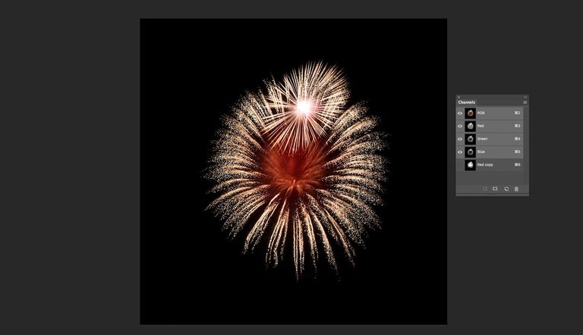
Use a keyboard command to load the copied channel as a selection.
Click on RGB in the channel palette to make all channels active and return to the color view of your image. Next from the Select menu, choose Load Selection. In the dialog box, choose "Red Copy". The explosion will be selected.
An even quicker way of doing this is to press the Command (Mac) or Ctrl (PC) key and click on the copied channel.

How To Tweak A Selection In Adobe Photoshop
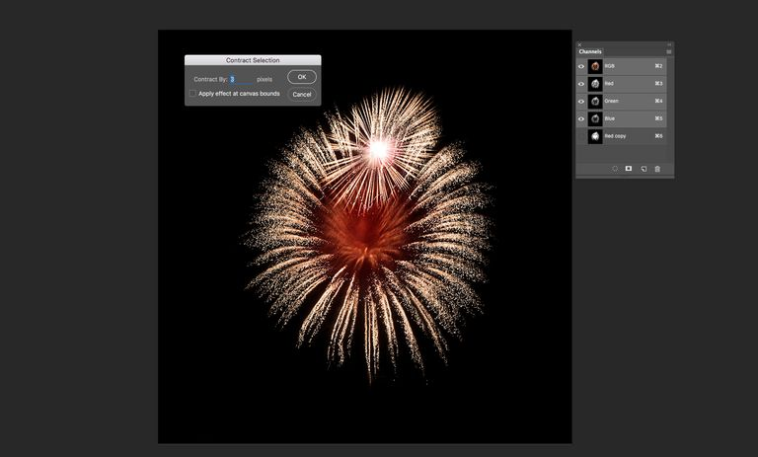
Shrink a selection to avoid hard edges and then feather the selection to smooth out the edges.
Before we remove the background let's talk about selections. Most edges are a little too sharp. With this flower there is still a bit of the green background. To fix that, head to Select>Modify>Contract. This will open the Contract Selection dialog box and I entered a value of 5 pixels. Click OK. Return to the Modify menu and this time select Feather. This will fade out the edge pixels. I used a value of 5.Click OK.

How To Invert A Photoshop Selection
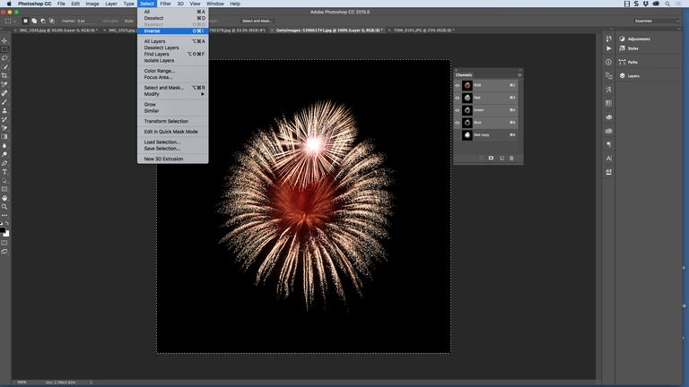
Use Select > Inverse or a keyboard command to reverse a selection.
Next, invert the selection by choosing Select > Inverse. Only the black area of the image is now selected and you can press delete to remove the background. Make sure your image is on a layer before hitting delete. If the layer palette shows only one layer labeled background, you must promote it to a layer by double clicking on the background in the layers palette.

How To Add A Layer To A Composite Image
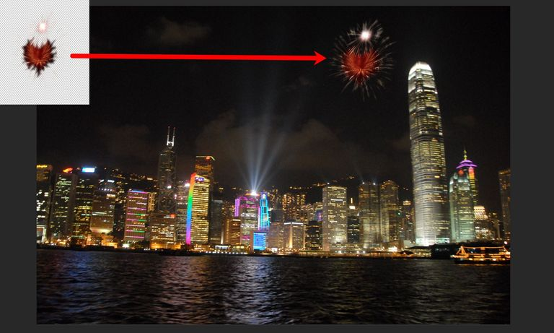
Use the Move tool to to add the image to a composite photo.
When you press Delete it may look like you are missing a lot of the explosion's tendrils. This is not the case.They have simply blended into the backgound checkerboard pattern. In this example I wanted to move the explosion to an image of the Hong Kong skyline at night. To do this I selected the Move tool and dragged the image to the Hong Kong image.

How To Use The Matting Options In Adobe Photoshop

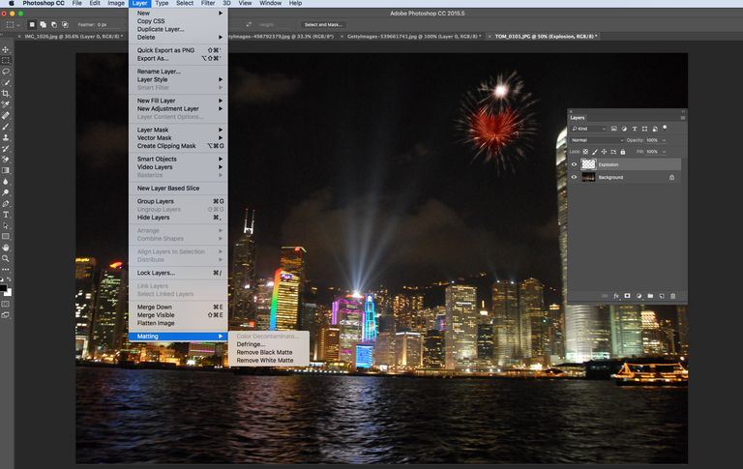
Apply a matting option to the new layer. Just be aware results may vary.
Any time you pull an image from its background, it's a good idea to try matting the image to have it fit into the composite image. All matting does is to smooth out any jagged edges. With the Layer in the composite selected, I chose Layer> Matting. You will have two choices.
Remove Black Matte and Remove White Matte are useful when a selection is anti-aliased against a white or black background and you want to paste it onto a different background.
Sometimes one will produce better results than another, and sometimes none of them appear to have any effect at all... it all depends on the combination of your foreground and background. But don't overlook them entirely because they can often make a world of difference. Defringe replaces the color of fringe pixels with the color of pixels further in from the edge of the selection that lack the background color.

